**Project Design Phase-II**

**Data Flow Diagram & User Stories**

|  |  |
| --- | --- |
| Date | 27 June 2025 |
| Team ID | LTVIP2025TMID59564 |
| Project Name | Edututor AI: personalized learning with generative AI and lms integration |
| Maximum Marks | 4 Marks |

**Data Flow Diagrams:**

A Data Flow Diagram (DFD) is a traditional visual representation of the information flows within a system. A neat and clear DFD can depict the right amount of the system requirement graphically. It shows how data enters and leaves the system, what changes the information, and where data is stored.

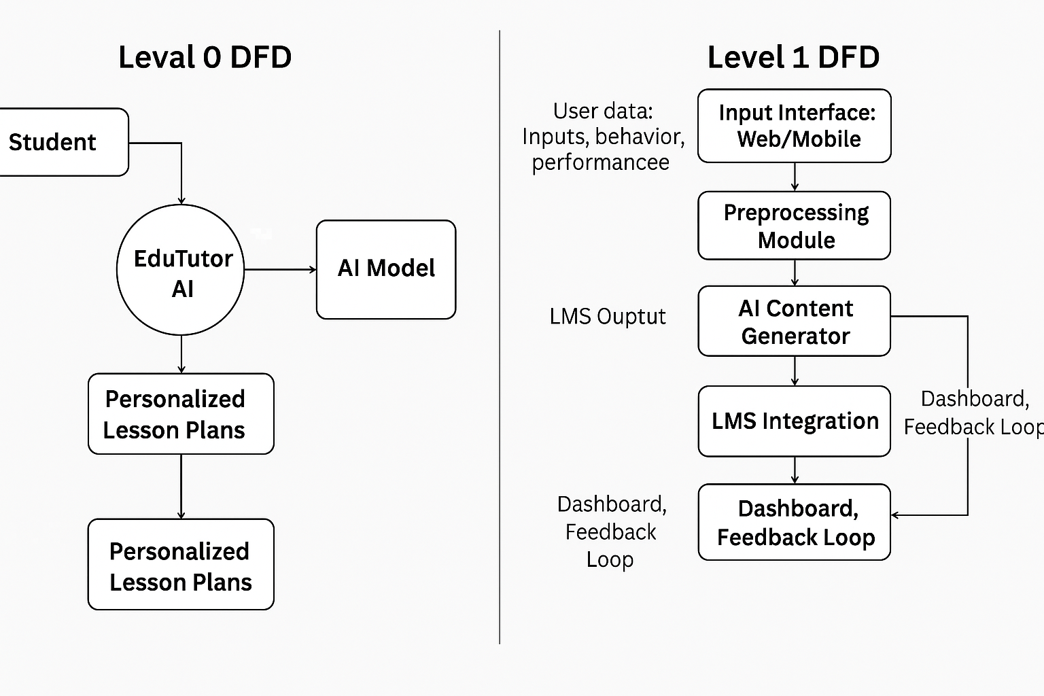

**User Stories**

|  |  |  |  |  |  |  |
| --- | --- | --- | --- | --- | --- | --- |
| **User Type** | **Functional Requirement (Epic)** | **User Story Number** | **User Story / Task** | **Acceptance Criteria** | **Priority** | **Release** |
| Student (Web/Mobile) | Registration | USN-1 | As a student, I can register using my email and password. | I can access my personalized dashboard after registration. | High | Sprint-1 |
| Student (Web/Mobile) | Registration | USN-2 | As a student, I receive a verification email after signing up. | I receive a confirmation email and can verify my account. | High | Sprint-1 |
| Student (Web/Mobile) | Registration  via Google | USN-3 | As a student, I can sign up using my Google account. | I can sign up and access the dashboard using Google Login. | Medium | Sprint-2 |
| Student (Web/Mobile) | Login | USN-4 | As a student, I can log in using my registered email and password. | I am redirected to my personalized dashboard after login. | High | Sprint-1 |
| Student (Web/Mobile) | Input Learning Preferences | USN-5 | As a student, I can input my learning goals, pace, and topics of interest. | System adapts content and displays my learning path. | High | Sprint-2 |
| Student (Web/Mobile) | Access Personalized Lessons | USN-6 | As a student, I can view personalized lesson plans generated by AI. | Lesson plans are tailored based on my preferences and progress. | High | Sprint-2 |
| Student (Web/Mobile) | Progress Tracking | USN-7 | As a student, I can view my performance and progress dashboard. | I can see charts/feedback on my learning progress. | Medium | |  | | --- | |  |  |  | | --- | | Sprint-3 | |
| Student (Web/Mobile) | Feedback on Lessons | USN-8 | As a student, I can rate and comment on lesson usefulness. | I can provide feedback and it is stored for AI tuning. | Low | Sprint-4 |
| Teacher / Admin | View Student Progress | USN-9 | As a teacher, I can view dashboards showing student learning progress. | I can see data visualizations and summaries per student. | Medium | Sprint-3 |
| Teacher / Admin | Adjust Lesson Plan | USN-10 | As a teacher, I can suggest manual changes to the AI-generated lesson plans. | I can override/edit lesson content for specific students. | Low | Sprint-4 |